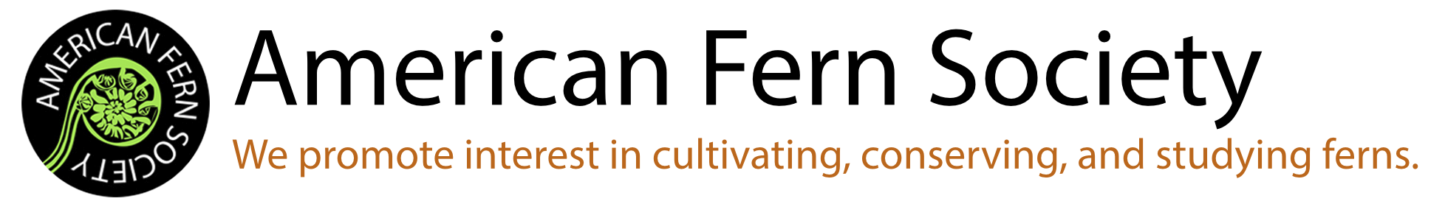

Spore Exchange Order Form

Please send this completed order form to the Spore Exchange Curator, Brian Aikins (spores.afs@comcast.net).
All inquiries about the spore exchange should also be directed to Brian; he checks email once per day.
Once he receives your order, Brian will get in touch with you about confirmation and payment information to complete your order.

Date: __________________________________________

Your name: __________________________________________

Your email: __________________________________________

Mailing address:

- Spore packets are 50 cents (USD) for each fern requested, plus 6% of the purchase amount to cover PayPal fees (payments made by check do not incur this fee).
- Payments via PayPal are preferred, but check is also acceptable.
- [Optional] Spore donation(s): When collecting spores, please follow the guidelines on the AFS spore collecting page: https://www.amerfernsoc.org/how-to-collect-spores
List spore requests by order number below, one per box (and please, only one of each). Order numbers can be found on the Spore Inventory list: https://www.amerfernsoc.org/spore-inventory.

In case some of your requests are no longer available, please list alternates in preference order:

